**OBJECT DETECTION**

**STEPS FOR VEHICLE DETECTION**

* Import necessary packages and initialize the network.
* Reads frames from a video file
* Pre-process the frame and run the detection.
* Track and count all vehicles on the road

**USES FOR VECHICLE DETECTION**

* Vehicles detection
* Counts the vehicles
* Average speed of individually vehicle
* Traffic analysis
* Vehicle categorizing objectives

Counts the vehicles

* Average speed of individual vehicle
* Traffic analysis
* Vehicle categorizing objectives

TABLE OF CONTENTS

* Vehicle detection uses are vehicle tracking
* Counts the vehicles
* Average speed of individual vehicle
* Traffic analysis
* Vehicle categorizing objectives

VARIOUS VEHICLE DETECTION

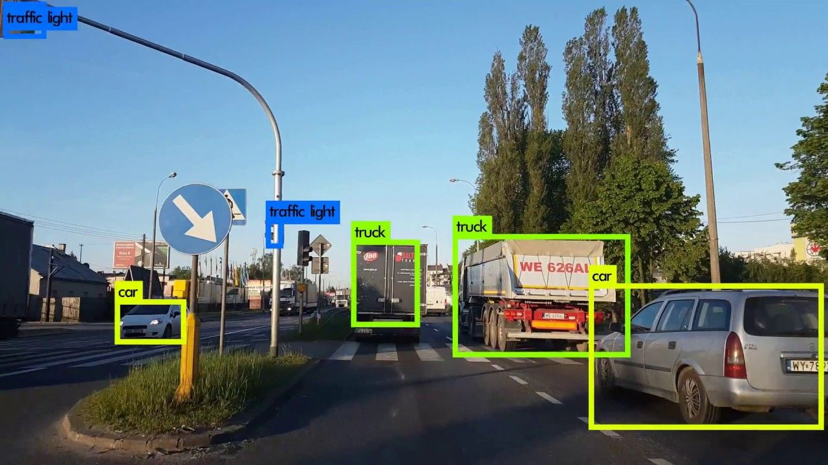

FLOWCHART

